Implement Slowly Changing Dimension Type 2 (SCD2) By using Joins
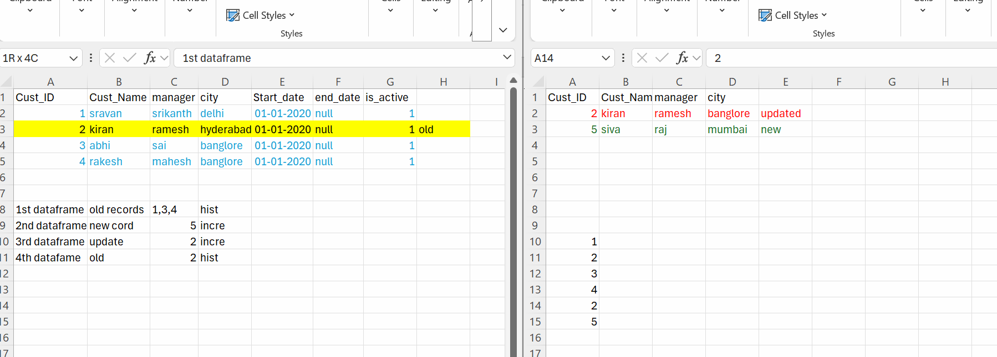
Steps:
- Read Dimension into DataFrame
- Read Source Delta Records into DataFrame
- Identify Old Records
- Identify Records to Update
- Identify Records to Insert
- Generate SCD2 Records
- Read Delta Format Dimension Data
- Implement SCD Type 2 with Python Merge Function
- Create Delta Table
- Implement SCD Type 2 in SQL
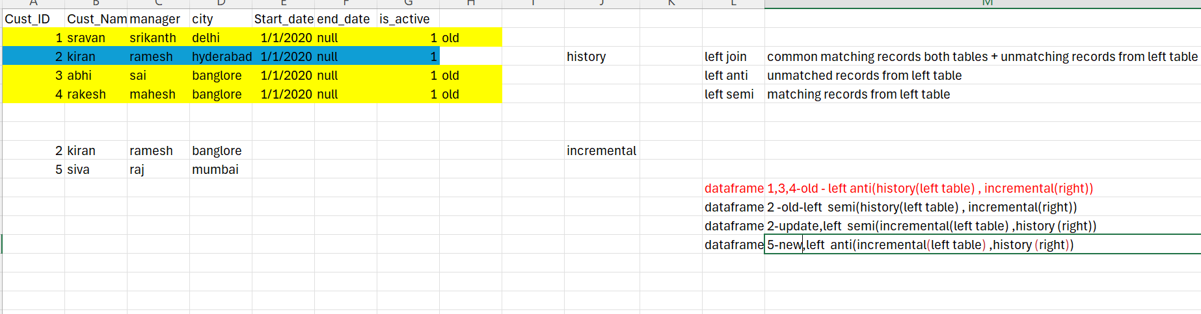

Step1: History data
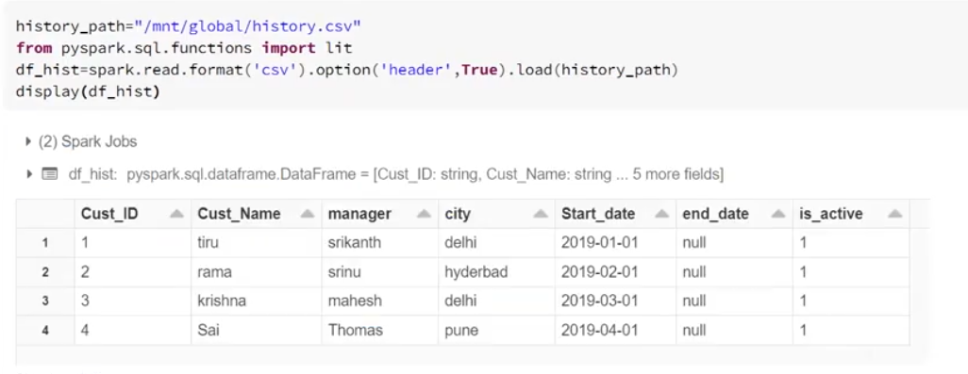
history_path="/mnt/source/history.csv"
from pyspark.sql.functions import lit
df_hist=spark.read.format('csv').option('header',True).load(history_path)
display(df_hist)

Step2: Incremental data
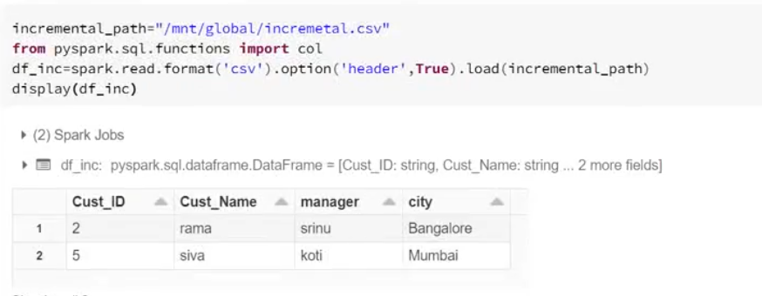
incremental_path="/mnt/source/incremental.csv"
from pyspark.sql.functions import lit
df_inc=spark.read.format('csv').option('header',True).load(incremental_path)
display(df_inc)

Step3: Here we need to get only common matching records from left table only not right table
Note: Old record from left table
Left semi means matched records from the left table only.
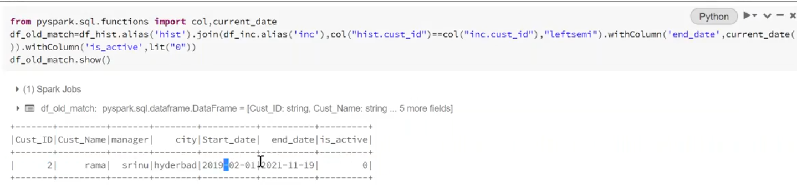
# /* left semi means matching records from the left table */
from pyspark.sql.functions import col, current_date
df_old_match=df_hist.alias('hist').join(df_inc.alias('inc'),col("hist.cust_id")==col("inc.cust_id"),"leftsemi").withColumn('end_date', current_date()).withColumn('is_active',lit("0"))
df_old_match.show()

Step4: Here Incremental table comes under left table and History table comes under right table, use same left semi to get common records from left table
Note: Updated record from Incremental table
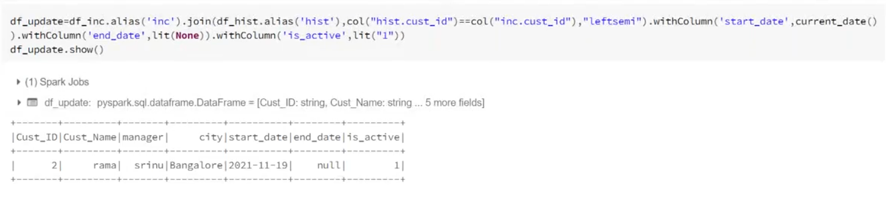
# /* left semi means matching records from the left table */
from pyspark.sql.functions import col, current_date
df_update=df_inc.alias('inc').join(df_hist.alias('hist'),col("hist.cust_id")==col("inc.cust_id"),"leftsemi").withColumn('start_date', current_date()).withColumn("end_date", lit(None).cast(DateType()))
withColumn('is_active',lit("1"))
df_update.show()

Step5: Here we need to get unmatched records from History table
Note: Old records here we are getting
Left anti means unmatched records from the left table.
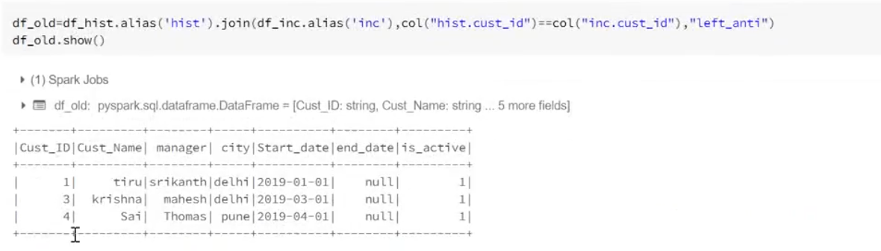
# /* left anti means un-matching records from the left table */
from pyspark.sql.functions import col, current_date
df_old=df_hist.alias('hist').join(df_inc.alias('inc'),col("hist.cust_id")==col("inc.cust_id"),"left_anti")
df_old.show()

Step6: Here we need to get new records from Incremental table
Left anti means unmatched records from the left table.

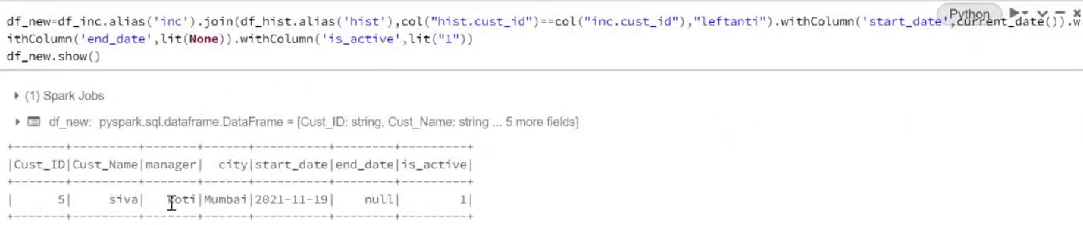
# /* left anti means un-matching records from the left table */
from pyspark.sql.functions import col, current_date
df_new=df_inc.alias('inc').join(df_hist.alias('hist'),col("hist.cust_id")==col("inc.cust_id"),"leftanti").withColumn('start_date', current_date()).withColumn('end_date',lit(None)).withColumn('is_active',lit("1"))
df_new.show()

Step7:
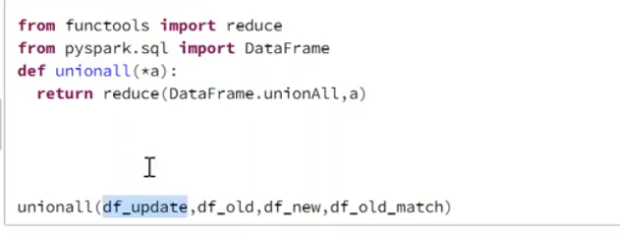
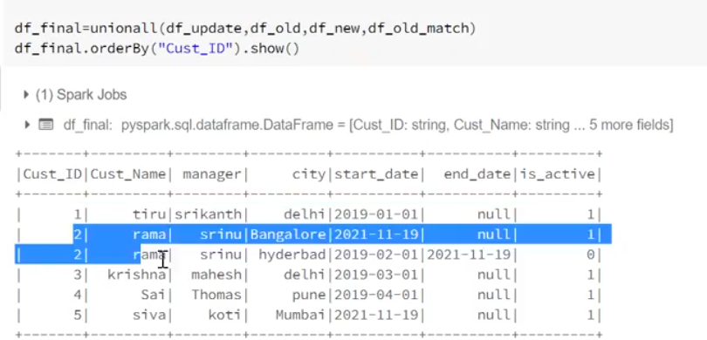

from functools import reduce
from pyspark.sql.functions import DataFrame
def unionall(*a):
return reduce(DataFrame.unionAll,a)
df_final=unionall(df_update,df_old,df_new,df_old_match)
df_final.orderBy("Cust_ID").show()

%python
finaldata.write.format("csv") \
.mode("overwrite") \
.option("header", "true") \
.option("sep", ",") \
.option("quote", "\"") \
.option("escape", "\"") \
.option("encoding", "UTF-8") \
.save("/mnt/silver/final.csv")

Date issue code:
from pyspark.sql.types import DateType
from pyspark.sql.functions import col, current_date, lit

df_update = (
df_inc.alias('inc')
.join(
df_hist.alias('hist'),
col("hist.cust_id") == col("inc.cust_id"),
"leftsemi"
)
.withColumn('start_date', current_date().cast(DateType()))
.withColumn('end_date', lit(None).cast(DateType()))
.withColumn('is_active', lit("1"))
)

display(df_update)

